RAG POC Technical Design: Smart and Overlap Chunking
This document describes the current local .NET RAG pipeline: format-aware extraction, word-based parent/child chunking, overlap, table-preserving chunks with TableId metadata, Ollama embeddings and LLM generation, Qdrant hybrid retrieval, and structure-aware context assembly.
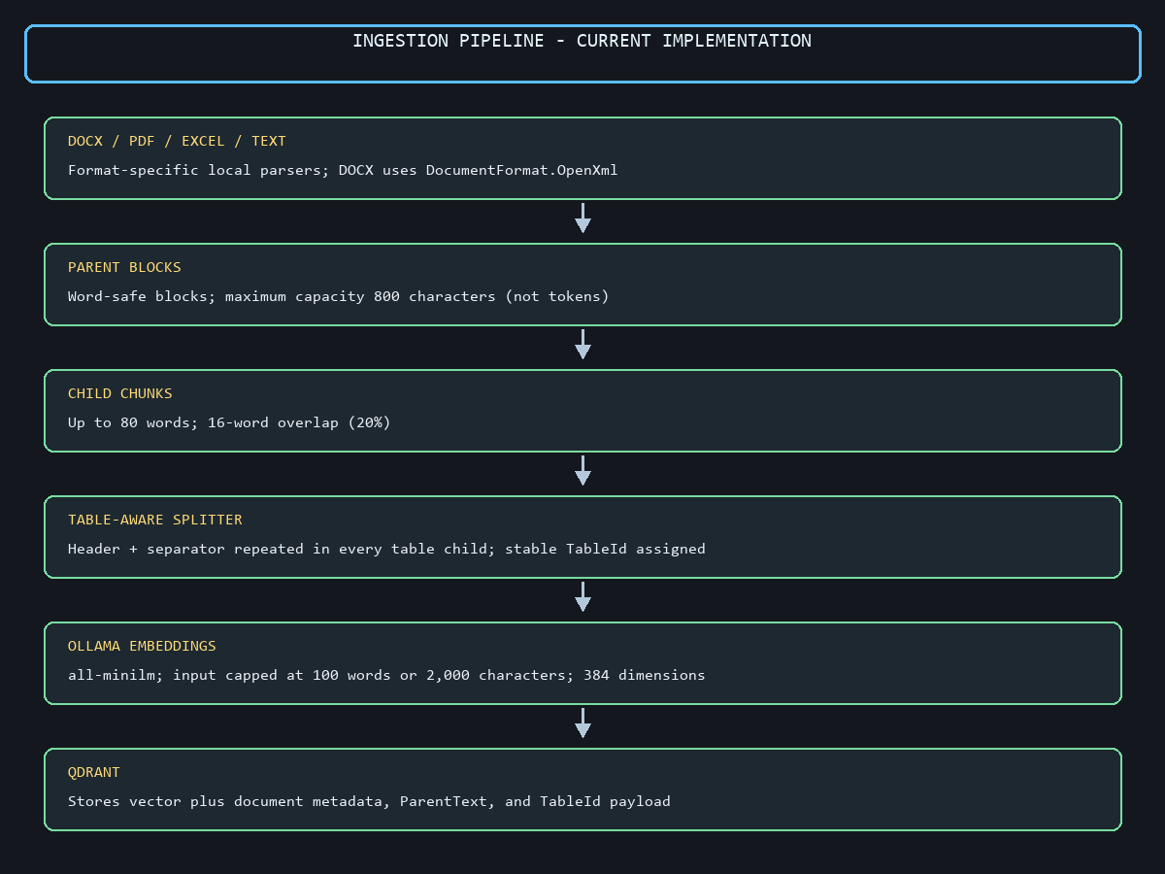
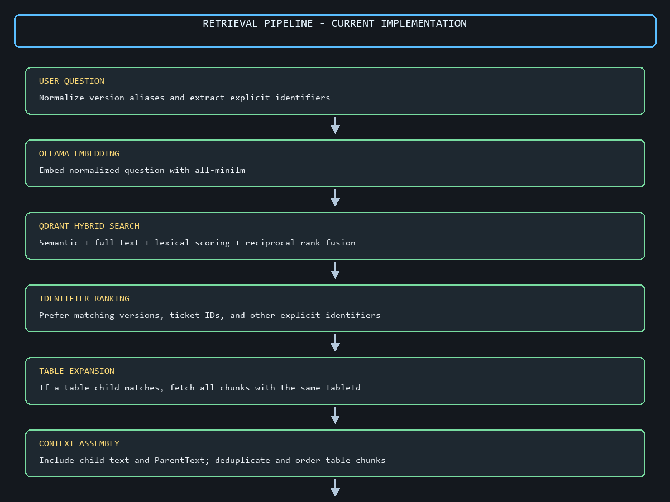

Smart And Overlap Chunk: Technical Design

1. The Core Problem
Fixed-size character splitting can break words, sentences, list items, and table rows. That causes incomplete context, incorrect answers, and ?Not found? responses even when the source document contains the answer.

2. The Solution Architecture
The application uses a Parent-Child strategy with word-safe chunking, sliding-window overlap, table-aware chunking, and local services. Document content is processed by .NET, embedded with Ollama all-minilm, indexed in Qdrant, and answered by the local Ollama llama3.2 model.

3. Phase Breakdown for Implementation
- Phase 1: Format-Specific Text Extraction (the Smart Parser)
  - Word (.docx): DocumentFormat.OpenXml reads document paragraphs, numbered/bulleted items, and tables. Tables are converted to Markdown-style text so their rows and columns remain understandable.
  - Excel (.xlsx): Use EPPlus or ExcelDataReader to read sheets row-by-row, translating tabular data into clean Markdown tables or structured text lines so rows stay grouped.
  - PDFs: Use a lightweight local text-extraction library (such as PdfPig in C#) to read text blocks layout-safely.

- Phase 2: Structure-Aware Parent-Child Generation
  - The extracted content is first organized into parent blocks. Child chunks are created without splitting words. Normal text uses a word window with overlap; Markdown tables use a table-specific splitter.
  - Parent Chunks: The parser creates word-safe parent blocks with a maximum capacity of 800 characters. This is a character limit. ParentText is stored with each child for context.
  - Child Chunks: Child chunks are the searchable units. The current configuration uses up to 80 words per child chunk and 16 overlapping words (20% of the 80-word child size).
    - Why overlap? It keeps boundary information available in more than one child chunk, improving recall when a fact, sentence, list item, or table row is near a chunk boundary.

- Phase 3: Local Embedding and Indexing
  - The contextual child text is sent to Ollama all-minilm(model) for a 384-dimensional(Vector size) embedding. The embedding input is capped at 100 words or 2,000 characters, whichever is reached first. The embedding generator limits input size to remain within the model context window.
  - Each Qdrant point stores the vector and payload metadata including document ID, document name, relative path, chunk number, child text, ParentText, document type, file type, and TableId when the chunk belongs to a table.

- Phase 4: Retrieval and LLM Generation
  - The user question is embedded and searched in Qdrant. Retrieval combines semantic vector search, Qdrant full-text search, lexical candidate scoring, identifier matching, reciprocal-rank fusion, and neighboring context.
  - Before retrieval, common version forms such as ?version 1.4?, ?version:1.4?, ?v1.4?, and ?v 1.4? are normalized consistently. Explicit identifiers such as versions and ticket IDs receive exact-match preference when matching content exists.
    - When a table child is selected, its TableId is used to fetch every child chunk from the same table. The chunks are ordered and added together so a split Project Timeline, Primary Keys table, or technology table is not treated as unrelated fragments.
  - The testing console sends the selected child content and bounded ParentText to the local llama3.2 model. The prompt requires answers to use only the supplied documentation context, preserve complete lists, and avoid mixing unrelated documents or sections.

